Math Practices:

- Make sense of problems and persevere in solving them.
- Reason abstractly and quantitatively
- Construct viable arguments and critique the reasoning of others.
- Model with mathematics.
- Use appropriate tools strategically.
- Attend to precision.
- Look for and make sense of structure.
- Look for and express regularity in repeated reasoning.

Science and Engineering Practices

1. Asking questions (for science) and defining problems (for engineering)
2. Developing and using models
3. Planning and carrying out investigations
4. Analyzing and interpreting data
5. Using mathematics and computational thinking
6. Constructing explanations (for science) and designing solutions (for engineering)
7. Engaging in argument from evidence
8. Obtaining, evaluating, and communicating information

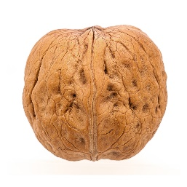
Math Practice: Questions for teachers to ask students in order to promote best math practice
Stem Questions to Promote the 8 Mathematical Practices
https://www.nd.gov/dpi/uploads/1382/QuestionStemsPromote8MathematicalPractices.pdf
Common Core State Standards, Standards for Mathematical Practice, Questions for Teachers to Ask
http://www.ride.ri.gov/Portals/0/Uploads/Documents/Instruction-and-Assessment-World-Class-Standards/Transition/EIA-CCSS/ScarpelliD-MP_TeacherQuestionStarters.pdf

