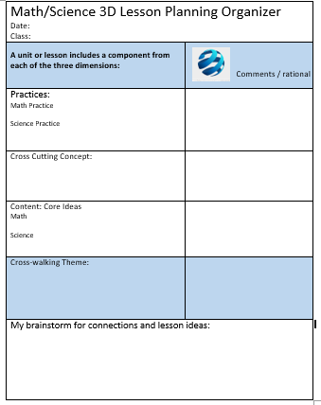
Crosscutting Concepts
Adapted from: A Framework for K-12 Education, and NGSS

The seven crosscutting concepts that allow us to connect different arenas of science, also cut across other academic content areas: Math, social studies, reading and writing.
1. Patterns. Observed patterns of forms and events guide organization and classification.
2. Cause and effect: Mechanism and explanation. Events have causes, sometimes simple, sometimes multifaceted that can then be tested and used to predict and explain events in new contexts.
3. Scale, proportion, and quantity. Recognize what is relevant at different measures of size, time, and energy and how changes affect a system’s structure or performance.
4. Systems and system models. Defining the system under study provides tools for understanding and testing ideas.
5. Energy and matter: Flows, cycles, and conservation. Tracking fluxes of energy and matter into, out of, and within systems helps one understand the systems’ possibilities and limitations.

6. Structure and function. The way in which an object or living thing is shaped and its substructure determine many of its properties and functions.
7. Stability and change. conditions of stability and determinants of rates of change are critical elements.

