What’s in our trash can?

In this lesson, we are going to take a look at what is in the trash can of an average household in the United States. We will show more than one way to display that information.

Students will:
- Reflect on their own knowledge of what is in their trash can.
- Look at Charts and graphs depicting the quantity of waste generated in the U.S. by category and per capita.
- Construct a bar graph to display the tonnage generated for nine categories of waste.
- Transform the information into a pie chart depicting percentage generation.
- Calculate the fraction of each material in tons (part over whole) and percent.
Give credit to EMPOWER lesson….
Materials: 2 sheets graph paper each student, scissors, tape, circular object or compass

Prompt:
What do you know?
Brainstorm what types of things we throw away in our municipal solid waste in the U.S.
How might you show this?

Compare:
Let’s compare our class Brainstorm to what the EPA says we throw away:
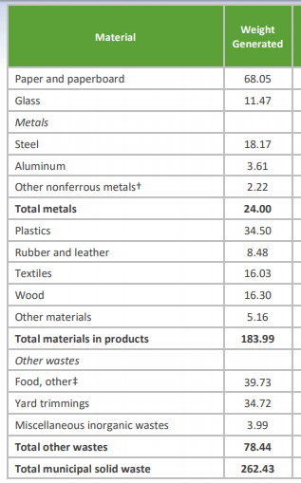

How do the materials thrown away compare to our brainstorm?

Note the categories:

Same chart with quantities for each category.

This chart shows the composition of the municipal waste generated in the U.S. in millions of tons per year for the whole country.

Categories.
Let’s combine a couple of small ones to make our task easier.

- Paper and Paperboard
- Glass
- Metals
- Plastics
- Rubber, Leather and Textiles
- Wood
- Food
- Yard Trimmings
- OTHER (include Other materials and Miscellaneous)

- Use this chart to make a bar graph showing the comparison of the nine categories listed and their weight generated. Use graph paper and have two squares equal ten tons.
- When complete, and after discussing the work, each student will LABEL EACH column (on the column or on the back of the paper).
- Cut out each column and tape them end to end.
- Close the loop so that the columns now form a paper circle.
- Place the paper circle on the second piece of graph paper. Carefully MARK THE CENTER of the circle. Very carefully, mark the INTERSECTION OF EACH CATEGORY BAR onto the piece of paper, equidistant from the center marked. Label the space between to mark the categories.
- With the compass or circular object, draw a circle with same center.
- Draw a line to connect the center of the circle to EACH CATEGORY INTERSECTION
- You have a pie chart. Label the sections.
- Calculate the fraction of each material in the original bar graph.
- Calculate the percentage of each material for your pie graph.

Extension:
How much do you predict that the average person throws away each day in pounds of trash per day? (per capita generation, lbs/person/day) - just municipal waste. Not construction or industry.

Teacher notes:
How much trash does an average US person generate per day? (4.5 lbs. 2015 - EPA)
The figures match to the population at the time. There were 321 million people in US in 2015.

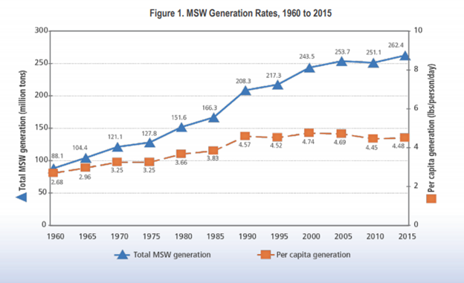

From: Advancing Sustainable Materials Management, 2015 Fact Sheet https://www.epa.gov/sites/production/files/2018-07/documents/2015_smm_msw_factsheet_07242018_fnl_508_002.pdf

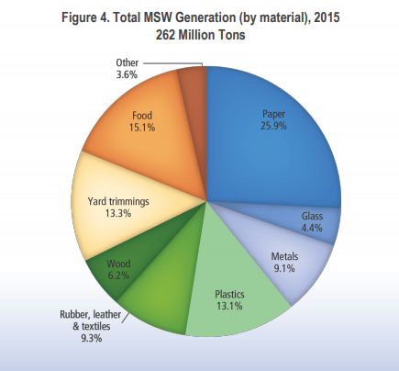

This is an example of a pie chart with the percentages generated from the previous materials chart and bar graph..

