Using “Recycling Energy Offsets” to reduce our energy footprint

In this lesson, we will take a look at where energy is used in our homes, and how we could “offset” or compensate for our use by saving energy recycling trash instead of landfilling it.

Students will:
- Research energy use of common household devices and appliances
- Use given energy saving figures for materials recycling
- Convert units of time, weight and energy to appropriate quantities
- Develop a “portfolio” of materials to offset their energy use
- Express this portfolio in fractional and percentage terms

Materials: Device for accessing online “Energy Use Calculator” site.
Handouts: Energy Saving Factoids of Material Recycling
Graphic Organizers: Recycling Conversions, My Energy Use, My Savings Portfolio

Goal:
The goal is to find out how much you would need to recycle or get others to recycle as “energy offsets” for your own energy use.

Definition:
What is an offset? The idea comes from the industry practice of carbon offsets:
carbon offset - noun
(plural: carbon offsets)
- an action intended to compensate for the emission of carbon dioxide into the atmosphere as a result of industrial or other human activity, especially when quantified and traded as part of a commercial program.
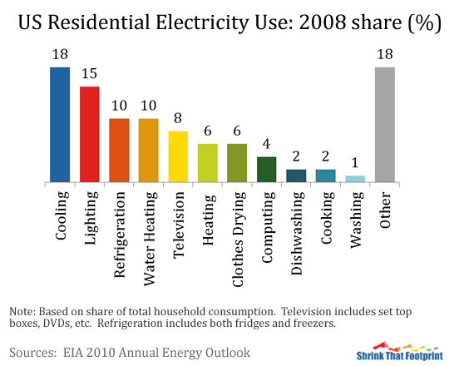
- "purchasing the carbon offsets would contribute to the airline's commitment to reducing its environmental impact"

Prompts:
Where do we use energy at home?

How many pounds of paper, cans, glass or plastic would we need to recycle in order to save enough energy to offset the energy we use at home for our devices, appliances and lights? Is it possible?

What do we need to know to answer this question? Where could we find the information?
- How much energy does someone use at home in a month?
- How much energy do your favorite electronics use? Your lights? Your refrigerator? How much would you need to recycle for each?
- What are the energy values of the different recyclable materials?

Resources:

Energy Use Calculator: http://energyusecalculator.com/
This site offers the energy use values for common household items.

Energy facts: (hand-outs included)
(websites)

Procedure:
- Look at charts of word energy use to find U.S. values.
Shrink That Footprint: http://shrinkthatfootprint.com/average-household-electricity-consumption
U.S. Energy Information Administration: https://www.eia.gov/outlooks/aeo/

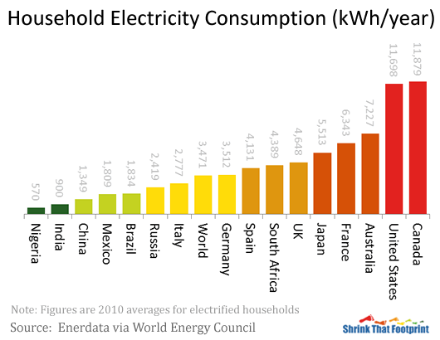

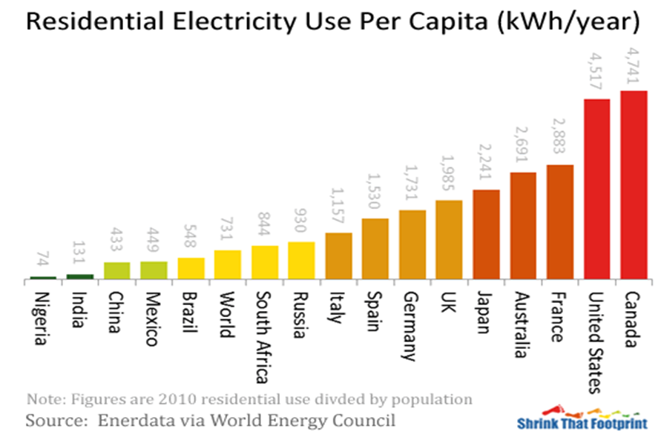
United States per capita – 4,517 kWh/year

- Visit the EnergyUseCalculator.com website to find values for your devices and appliances

My Energy Use
(Collect your information from Energyusecalculator.com) | Kw per day | Kw per month | Kw per year
Laptop Computer (example) | .36 | 10.8 | 131.4
Total Use
Compare to US per capita figure from EPA chart |  |  | 4517  kWh per year

- Use the handouts of Energy Saving Factoids of Material Recycling to convert values for recycling material commodities.

Recycling Conversions
(Convert information from Energy Saving Factoids handout)  Commodity | Energy savings per ton | Energy savings per pound
Office Paper
Newspaper
Aluminum Cans
Steel
PET containers
Other plastic
Glass
Paper:
- One ton of recycled office paper saves 4,100 kWh of energy
- One ton of recycled newsprint saves 601 kWh of energy
- One ton of cardboard saves 390 kWh of energy

Aluminum Cans:
- A ton of soda cans made with recycled aluminum saves 21,000 kilowatt hours

Steel:
- One ton of recycled steel saves 642 kWh of energy

Plastic containers:
- A ton of PET plastic containers made with recycled plastic conserves about 7,200 kilowatt hours.
- One ton of recycled plastic saves 5,774 kWh of energy,

Glass Bottles:
- one glass bottle saves enough energy to light a 100-watt light bulb for four hours.
- One ton of recycled glass saves 42 kWh of energy

Sources: Stanford University and PSSI/ Stanford Recycling
https://lbre.stanford.edu/pssistanford-recycling/frequently-asked-questions/frequently-asked-questions-benefits-recycling

Waste Management
http://www.wm.com/location/california/san-joaquin/stockton/facts/index.jsp
- Calculate the pounds of each commodity needed to offset your device energy use.

 | My Energy Offsets Possibility
Single commodity options explored |  | Item uses  Kw per month  From My Energy Use | Office paper  (lbs. needed) | Newspaper  (lbs. needed) | Aluminum  (lbs. needed) | Steel  (lbs. needed) | PET Plastic  (lbs. needed) | Glass  (lbs. needed)
Home item |  | Use
Laptop Computer |  | 10.8 | 5 lbs. | 36
TOTALNEEDED of each commodity if it alone were to cover the energy use

- Mix and Match your recyclable commodities to create a reasonable portfolio of materials to recycle to offset your energy use. What fraction of your portfolio comes from each commodity? What percentage? Why did you choose what you did? ``
 |  |  |  |  | My Energy Offsets Portfolio
MY PLAN  Mix and match | Item uses  Kw per month |  | Office paper |  |  | Newspaper  (lbs. needed) |  | Aluminum  (lbs. needed) |  | Steel  (lbs. needed) |  | PET Plastic  (lbs. needed) |  | Glass  (lbs. needed) |  | totals  lbs.  kWh
 | kWh From My Energy Use |  | Lbs | kWh savings |  | Lbs | kWh savings | Lbs | kWh savings | Lbs | kWh savings | Lbs | kWh savings | Lbs | kWh savings
Values from Offset Possibility chart
My personal mix |  |  |  |  |  |  |  |  |  |  |  |  |  |  |  | lbs  kWh
fractions
Fraction reduced
Fraction rounded/ benchmark
Percent | 100%

